## GATEBOX: PARTS LIST (SIMPLIFIED)

By Shafeeq Rabbani

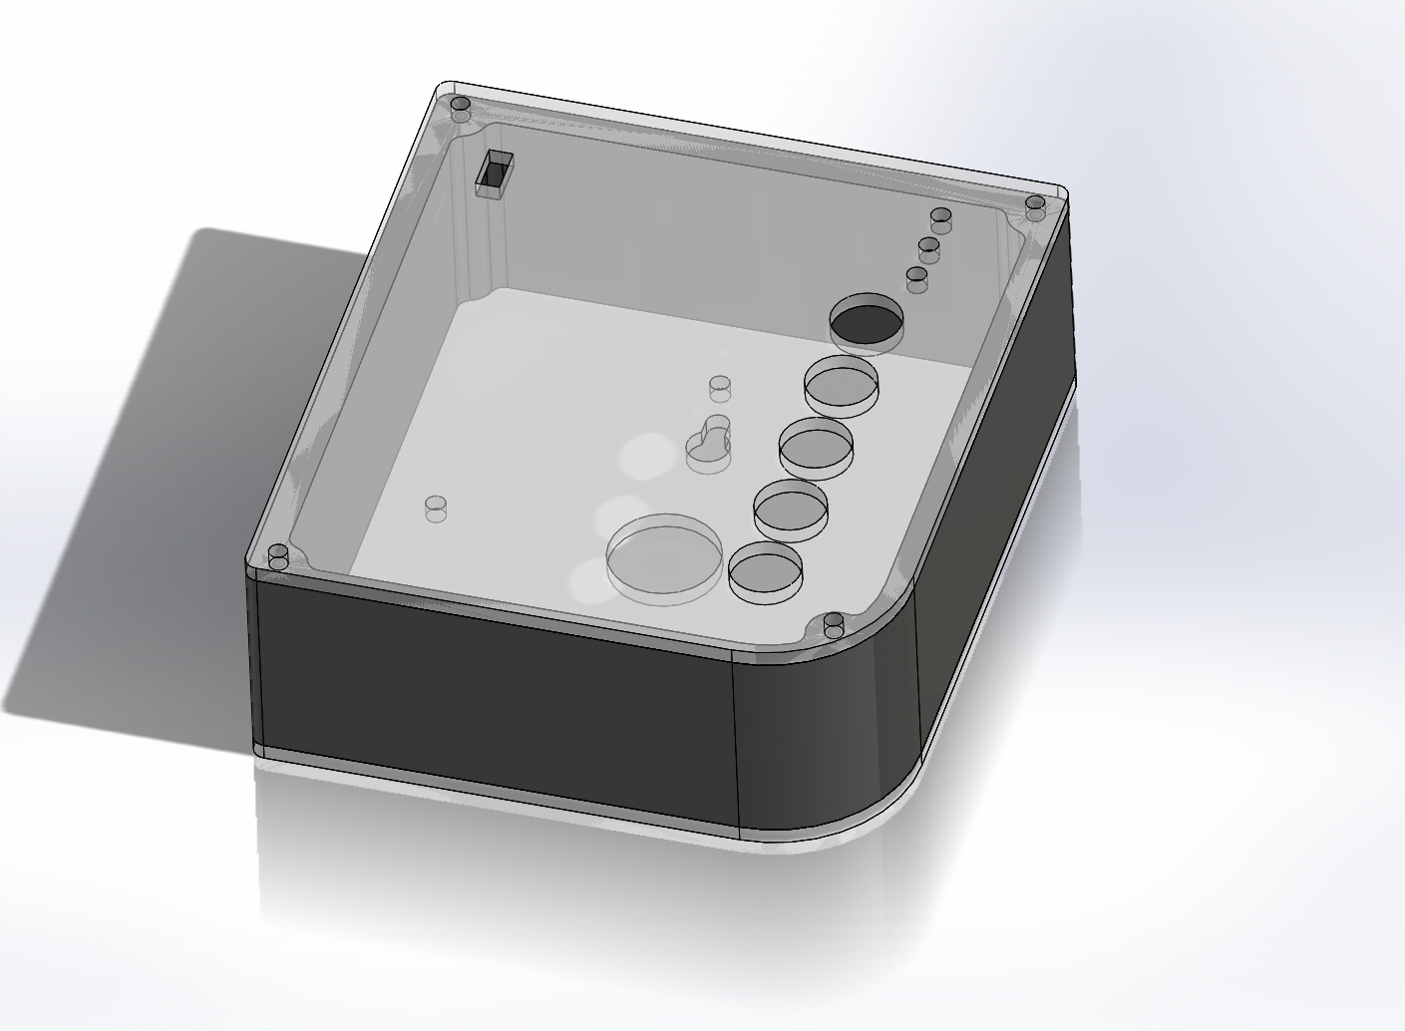

Contents

[GATEBOX: PARTS LIST (SIMPLIFIED) 1](#_Toc445432779)

[Introduction 2](#_Toc445432780)

[What you will need: 2](#_Toc445432781)

[Parts List for Option A and B 3](#_Toc445432782)

[Parts List for Option C 5](#_Toc445432783)

## Introduction

This parts list is where we recommend you start testing this project. It is considered simplified because rather than making the complex circuitry of the Bluetooth Low Energy chip, we use a pre-existing chip. You can approach this in the following ways:

1. You can use an Arduino UNO board, a Bluetooth Low Energy Chip and a perf board for the relay circuitry. **This is the simplest possible approach to this project.**
2. You can use an Arduino UNO board, a Bluetooth Low Energy Chip and a PCB (from PCB V7.brd). This is a lot like the previous method but can speed up development since you will not have to solder as many parts. As you are already using an Arduino UNO, you will not have to solder all the parts on the resulting PCB.
3. You can solder all the components on the PCB V7.brd board (the PCB has place for Arduino UNO’s components) and use a Bluetooth Low Energy chip.

## What you will need:

1. As the GateBox device is expected to be up and running for 24/7, you will require a 5V DC power supply that can power the Arduino UNO.
2. A Bluetooth Low Energy module from Nordic Semiconductors called “nRF8001”. There are two options you can choose from that already have the circuitry built in.

|  |  |
| --- | --- |
| **Option 1** | **Option 2** |
| The Adafruit Bluetooth Low Energy nRF8001 breakout board (<https://www.adafruit.com/product/1697>) | The RedBearLab BLE shield (<http://redbearlab.com/bleshield/>) |
| C:\Users\Shafeeq\Downloads\IMG_20160307_050105.jpg | C:\Users\Shafeeq\Downloads\IMG_20160307_010331.jpg |

## Parts List for Option A and B

|  |  |  |  |  |  |  |
| --- | --- | --- | --- | --- | --- | --- |
| Part | Digikey/ Element14 Part No. | | Manufacturer Part No. | Quantity | Picture | Cost (CANADIAN $) |
| ARDUINO UNO REV 3 | 1050-1024-ND | | A000066 | 1 | A000066 Arduino | 1050-1024-ND DigiKey Electronics | 33.43 |
| Terminal blocks | ED1623-ND | | ED500/2DS | 4 | ED500/2DS On Shore Technology Inc | ED1623-ND DigiKey Electronics | 0.85 |
| 3mm LED, FWD V= 2.1V  FWD I= 20mA | 94T8843 | | 703-0087 | 3 | http://www.custobots.com/sites/default/files/imagecache/product_full/products/Solarbotics-redLED.gif | $0.184 |
| 10K Ω Resistor, 1W, 5% | 95W5667 | | CFR100J10K | 8 | http://i00.i.aliimg.com/wsphoto/v1/724668692/Carbon-film-resistor-10kOhm-1w-5-Tolerance-100pcs-free-shipping-of-China-POST.jpg_350x350.jpg | $0.18 |
| 1K Ω Resistor, 1/4W, 5% | 25M8365 | | CBT25J1K0 | 7 | http://www.digchip.com/datasheets/photos/1838/CFR-25JB-1K0.jpg | $0.32 |
| 6 Pin Male Header | 609-3263-ND | | 68000-406HLF | 4 | 68000-406HLF FCI | 609-3263-ND DigiKey Electronics | $0.24 |
| G5V-1-DC Low Signal Relay | | Z773-ND | G5V-1-DC5 | 4 | G5V-1-DC5 Omron Electronics Inc-EMC Div | Z773-ND DigiKey Electronics | 2.77 |
| SPDT Sliding Switch | | CKN9565-ND | OS102011MS2QN1 | 1 | OS102011MS2QN1 C&K Components | CKN9565-ND DigiKey Electronics | 0.54 |
| DIODE GEN PURP | | 1N4148TACT-ND | 1N4148TA | 4 | 1N4148TA Fairchild Semiconductor | 1N4148TACT-ND DigiKey Electronics | 0.14 |
| Transistor NPN | | 2N3904FS-ND | 2N3904BU | 4 | 2N3904BU Fairchild Semiconductor | 2N3904FS-ND DigiKey Electronics | 0.26 |
| SWITCH PUSH SPST-NO | | EG1900-ND | RP3502ABLK | 5 | RP3502ABLK E-Switch | EG1900-ND DigiKey Electronics | 2.80 |
| Prototype Board (Not needed for Option B) | | Any brand of your choosing | Any brand of your choosing | 1 | C:\Users\Shafeeq\Downloads\IMG_20160310_230405.jpg | - |
| 24-30 AWG wire (For connections on perf board. Alternatively, you can strip open a CAT5 cable and use the one of the 8 small wires instead.) | | Any brand of your choosing | Any brand of your choosing | - | https://upload.wikimedia.org/wikipedia/commons/c/cb/UTP_cable.jpg | - |
| Soldering iron and Solder | | Any brand of your choosing | Any brand of your choosing | - | - | - |

## Parts List for Option C

|  |  |  |  |  |  |  |
| --- | --- | --- | --- | --- | --- | --- |
| Part | Digikey/ Element14 Part No. | | Manufacturer Part No. | Quantity | Picture | Cost (CANADIAN $) |
| Atmega 328p Microcontroller | 68T2944 | | ATMEGA328P-PU | 1 | http://shop.emscdn.com/catalog/components/semi/mcu/atmega328p/imglrg/1.jpg | $3.24 |
| 16 MHz Crystal Oscillator | 18C1481 | | XT9S20ANA16M | 1 | http://orzparts.com/images/16MHZ.jpg | $0.338 |
| 28 pin DIP IC Socket | 34P8056 | | 4828-3004-CP | 1 | http://media.digikey.com/photos/3M%20Photos/4828-3004-CP.jpg | $0.503 |
| Rectifier Diode 1A, 50V | 10M8464 | | 1N4001 | 1 | http://media.digikey.com/photos/Fairchild%20Semi%20Photos/261-DO-41.jpg | $0.113 |
| LM-7805-CT Linear Voltage Regulator | MC7805CTG | | MC7805CT-BPMS-ND | 1 | http://www.learningaboutelectronics.com/images/LM7805.jpg | $0.487 |
| Terminal blocks | ED1623-ND | | ED500/2DS | 4 | ED500/2DS On Shore Technology Inc | ED1623-ND DigiKey Electronics | 0.85 |
| 2.1mm DC Barrel Jack | CP-037A-ND | | PJ-037A | 1 | DC Barrel Power Jack/Connector | $1.23 |
| 100uF, 25V Aluminum Electrolytic Capacitor | 39T8695 | | 25YXH100MEFC6.3X11 | 2 | http://ecx.images-amazon.com/images/I/31IHAvewH7L._SX342_.jpg | $0.075 |
| 22 pF, 50 V Ceramic Capacitors | BC1034TR-ND | | K220J15C0GF5TH5 | 2 | http://www.famosastudio.com/image/cache/data/Ceramic%20Capacitor%2022pF-500x500.jpg | $0.34 |
| 3mm LED, FWD V= 2.1V  FWD I= 20mA | 94T8843 | | 703-0087 | 3 | http://www.custobots.com/sites/default/files/imagecache/product_full/products/Solarbotics-redLED.gif | $0.184 |
| 10K Ω Resistor, 1W, 5% | 95W5667 | | CFR100J10K | 8 | http://i00.i.aliimg.com/wsphoto/v1/724668692/Carbon-film-resistor-10kOhm-1w-5-Tolerance-100pcs-free-shipping-of-China-POST.jpg_350x350.jpg | $0.18 |
| 1K Ω Resistor, 1/4W, 5% | 25M8365 | | CBT25J1K0 | 7 | http://www.digchip.com/datasheets/photos/1838/CFR-25JB-1K0.jpg | $0.32 |
| 6 Pin Male Header | 609-3263-ND | | 68000-406HLF | 4 | 68000-406HLF FCI | 609-3263-ND DigiKey Electronics | $0.24 |
| G5V-1-DC Low Signal Relay | | Z773-ND | G5V-1-DC5 | 4 | G5V-1-DC5 Omron Electronics Inc-EMC Div | Z773-ND DigiKey Electronics | 2.77 |
| SPDT Sliding Switch | | CKN9565-ND | OS102011MS2QN1 | 1 | OS102011MS2QN1 C&K Components | CKN9565-ND DigiKey Electronics | 0.54 |
| DIODE GEN PURP | | 1N4148TACT-ND | 1N4148TA | 4 | 1N4148TA Fairchild Semiconductor | 1N4148TACT-ND DigiKey Electronics | 0.14 |
| Transistor NPN | | 2N3904FS-ND | 2N3904BU | 4 | 2N3904BU Fairchild Semiconductor | 2N3904FS-ND DigiKey Electronics | 0.26 |
| SWITCH PUSH SPST-NO | | EG1900-ND | RP3502ABLK | 5 | RP3502ABLK E-Switch | EG1900-ND DigiKey Electronics | 2.80 |